PLANNING

**Breakout game with gyroscope controller using Thread/Matter**

for Dekimo Turnhout



Document: 20231215*- Planning*

Date: December 15, 2023

Table of contents

1 PLANNING PROPOSAL 3

1.1 Proposal 1 3

1.2 Proposal 2 3

2 Document Information 3

2.1 Version History 3

2.2 Related Documents 4

2.3 Non-Trivial Abbreviations and Project-Specific Terminology 4

PLANNING

**Breakout game with gyroscope controller using Thread/Matter**

for Dekimo Turnhout

# PLANNING PROPOSAL

PLANNING

**Breakout game with gyroscope controller using Thread/Matter**

for Dekimo Turnhout

## Proposal 1

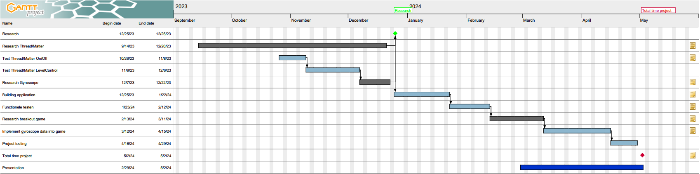

See 20231201 - ProjectPlanning.pdf

## Proposal 2

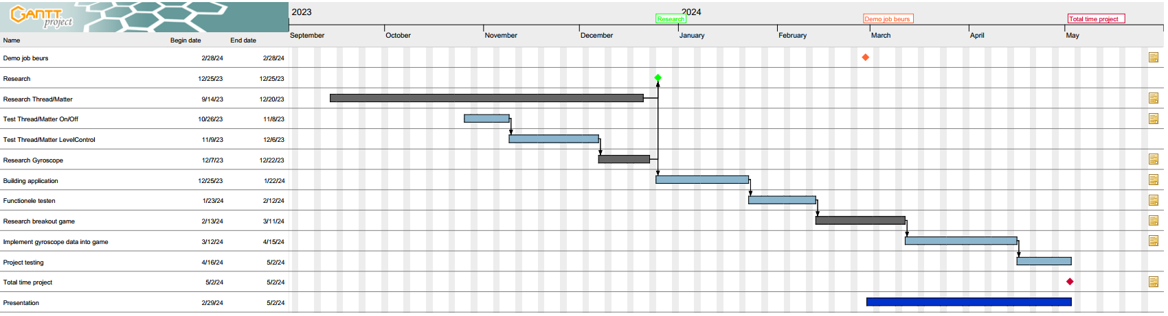

See 20231215 - ProjectPlanning.pdf

Remarks:

Added Demo job beurs, this is a milestone. A demo example must be finished then.

# Document Information

## Version History

|  |  |  |  |
| --- | --- | --- | --- |
| **Date** | **Author** | **Version** |  |
| 01/12/2023 | BGY | 0.1 | Initial Draft |
| 15/12/2023 | BGY | 0.2 | Update planning |
|  |  |  |  |
|  |  |  |  |
|  |  |  |  |
|  |  |  |  |
|  |  |  |  |
|  |  |  |  |

## Related Documents

|  |  |
| --- | --- |
| **Ref** | **Description** |
| 231018-01 Planning.pdf | Planning |
| 231019-01 Planning.pdf | Planning |
| 231025-01 Planning (with custom devkit).pdf | Planning |
|  |  |
|  |  |
|  |  |
|  |  |
|  |  |
|  |  |
|  |  |

## Non-Trivial Abbreviations and Project-Specific Terminology

|  |  |
| --- | --- |
| **Abbreviation** | **Explanation** |
|  |  |
|  |  |
|  |  |
|  |  |
|  |  |
|  |  |
|  |  |
|  |  |
|  |  |
|  |  |